Setup Visual Studio with Github Repo for Pinewood Derby

Table of Contents

Connect to Github with Visual Studio Code 3

Update PEM / Key in Github Repo 8

# Connect to Github with Visual Studio Code

1. Navigate to [majora15/Pack442PineWoodDerby-main (github.com)](https://github.com/majora15/Pack442PineWoodDerby-main).
2. Click the down arrow by Code.
3. Click **Download ZIP**.

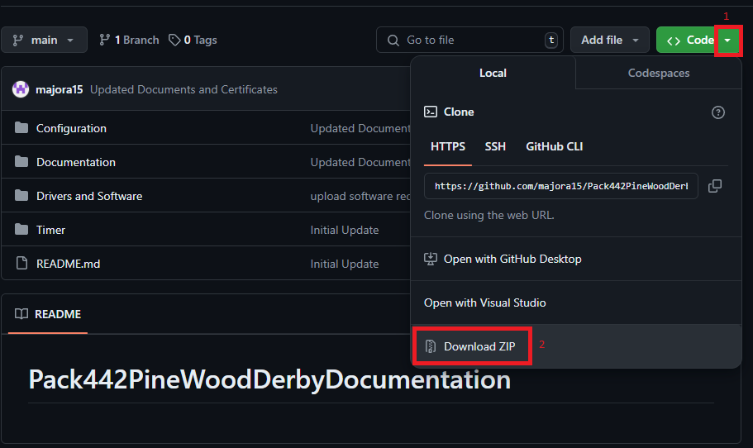

1. Exact the files in a location you choose. 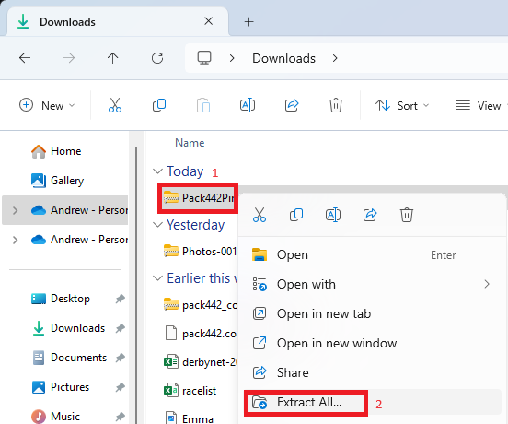
2. Select the location to exact the files. Remember this location as you will need it later.
3. Click **Extract**.

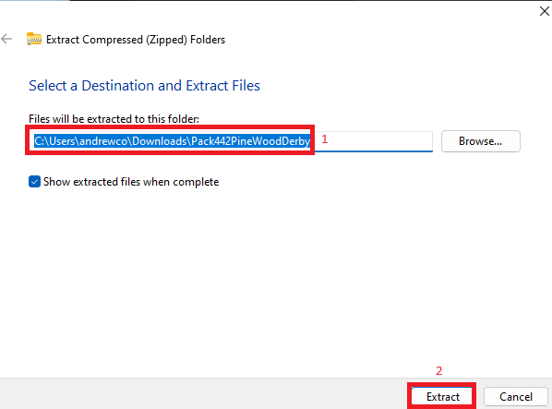

1. Open **Visual Studio Code**.

NOTE: If you don’t have Visual Studio Code, you can download it from: [Download Visual Studio Code - Mac, Linux, Windows](https://code.visualstudio.com/download).

1. Click **Source Code >** Click **Open Folder**.

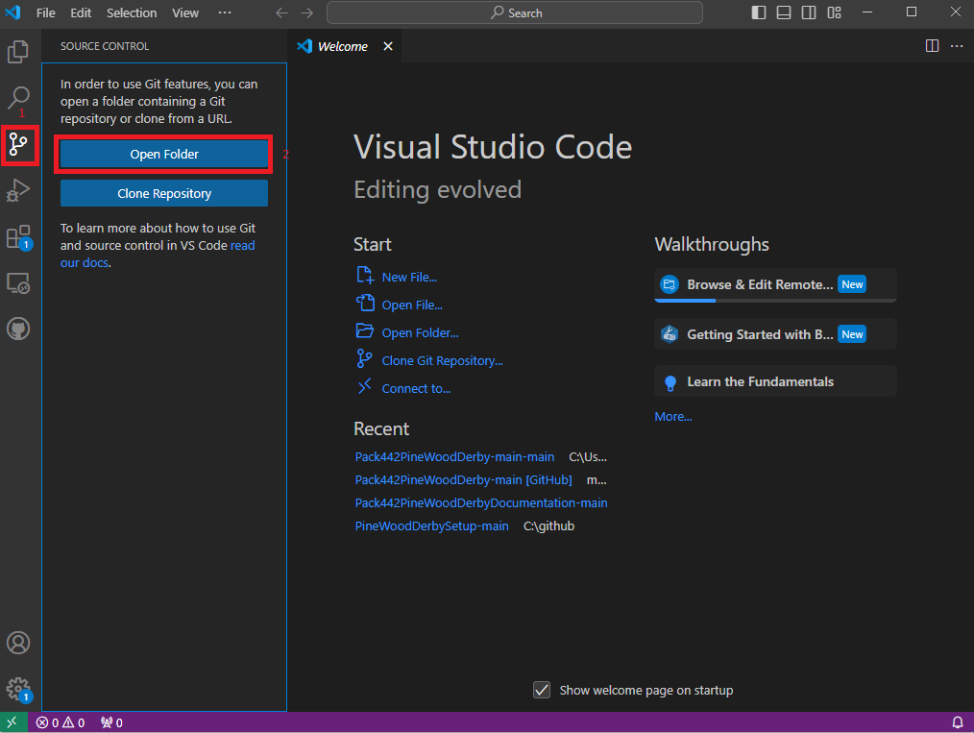

1. Select the location you exacted the files, and navigate to Pack442PinewoodDerby-main. You will see the configuration, documentation, drivers and software, and timer folder.
2. Click **Select Folder** on this location.

1. Click **Source Control >** Click **Initialize Repository**.

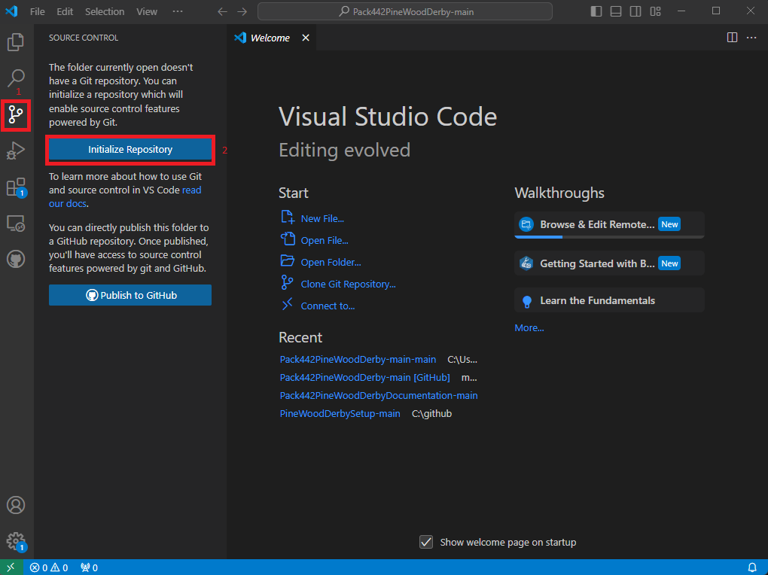

1. Click on the **+.**
2. Type **Update** in the text box above Commit.
3. Click **Commit**.

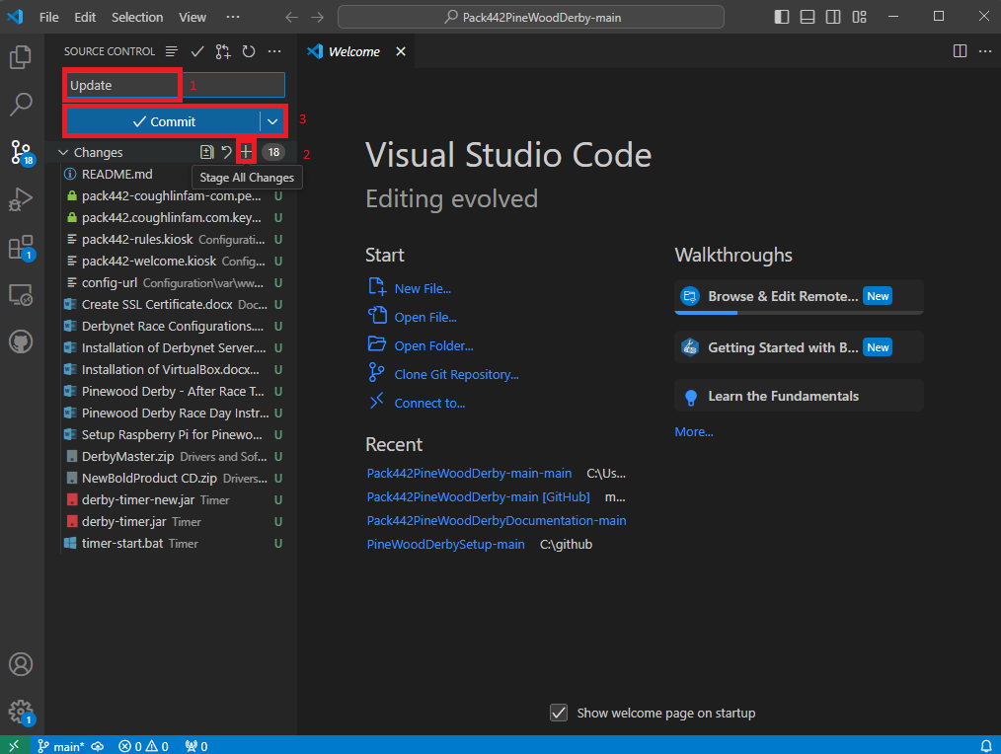

1. Click **Publish Branch**.

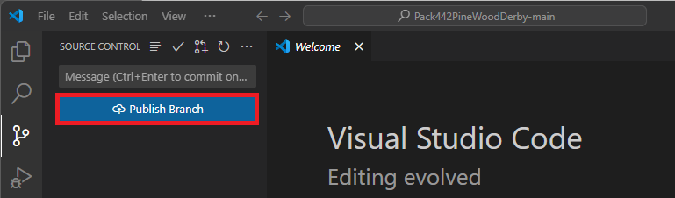

1. Click **Publish to GitHub public repository**.

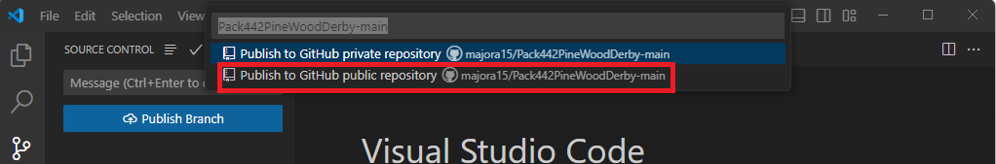

1. When completed you will get a successful published file message.

# Update PEM / Key in Github Repo

1. Type **WinSCP** **>** Click **WinSCP**.

1. Type the ip address of the virtual machine.
2. Type the following:

Username: pack442

Password: pack442

1. Click **Login**.

1. Click **Yes / Accept**.

1. Drag the pack442_coughlinfam_com.key file you created earlier to the same location as the .pem file.

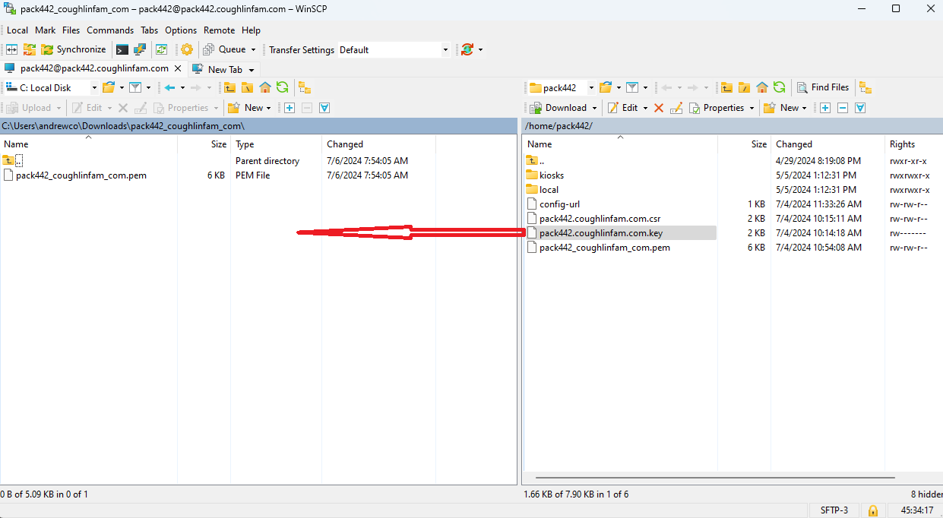

1. Navigate to where you saved the .pem file when you downloaded it.
2. Right click pack442_coughlinfam_com.pem.
3. Click **Copy**.

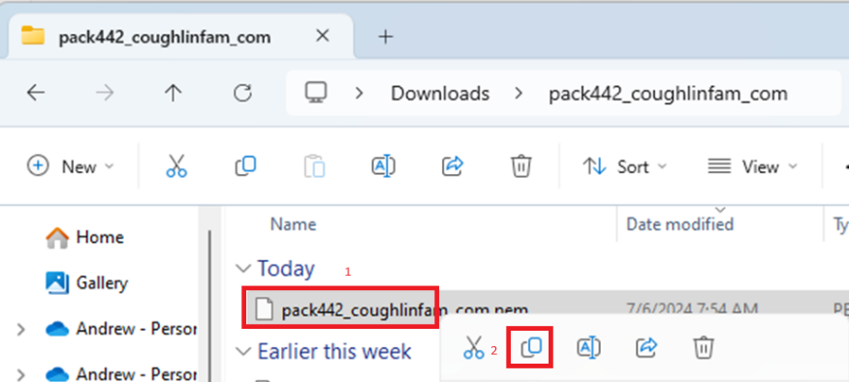

1. Navigate to the location you exacted the github.zip file. Click on **Configuration >** Click on **etc >** Click on **ssl >** Click on **certs**.
2. Right click and click **Paste**.

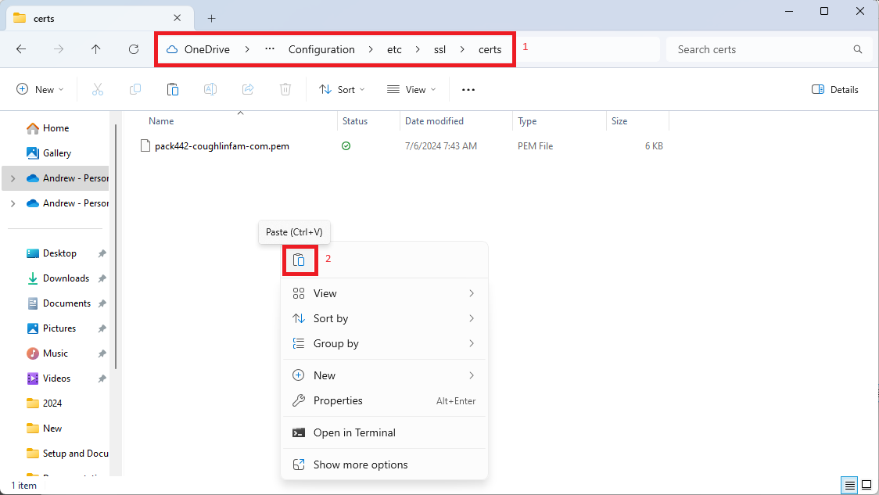

1. Right click pack442-coughlinfam-com.pem.
2. Rename pack442-coughlinfam-com.pem to pack442.coughlinfam.com.pem.old.

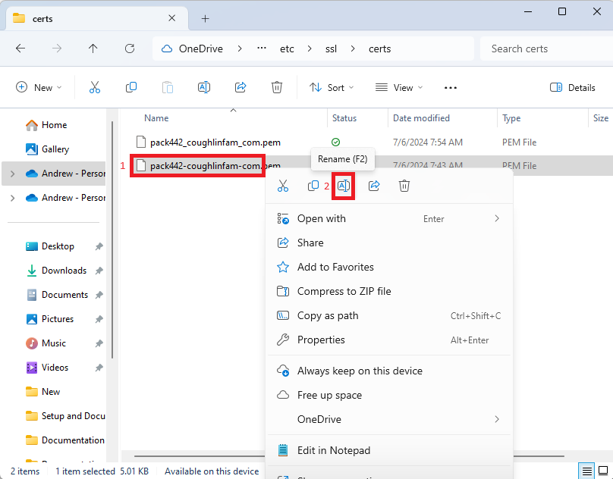

1. Rename pack442_coughlinfam_com.pem to pack442-coughlinfam-com.pem.

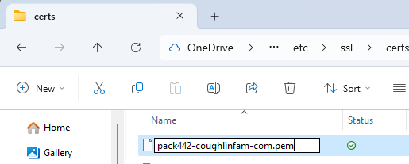

1. Navigate to the location you exacted the github.zip file. Click on **Configuration >** Click on **etc >** Click on **ssl >** Click on **private**.
2. Right click pack442.coughlinfam.com.key.
3. Click **Rename**.

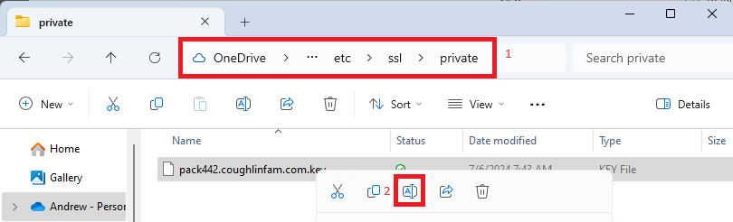

1. Navigate to where you transferred the .key file.
2. Right click on it and click **copy**.

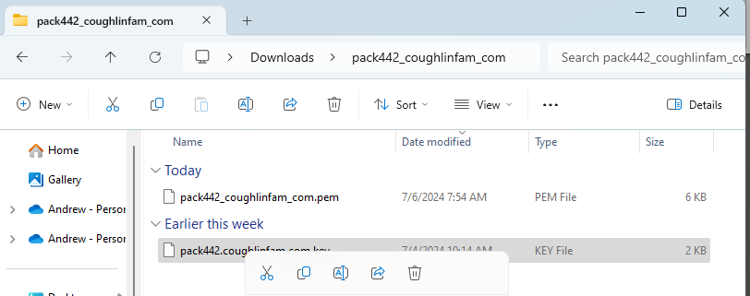

1. Navigate to the location you exacted the github.zip file. Click on **Configuration >** Click on **etc >** Click on **ssl >** Click on **private**.
2. Right click and paste the file.

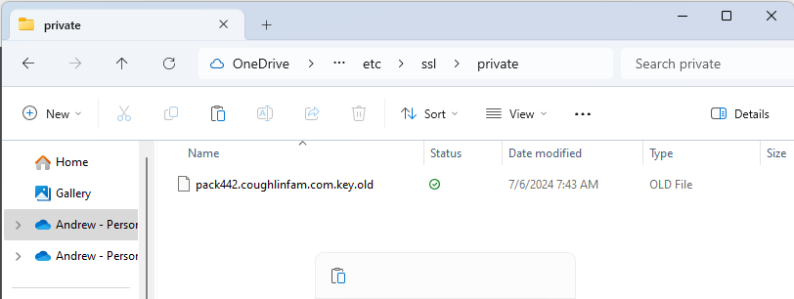

1. Switch back to Visual Studio Code.
2. Click **Source Control >** Click **+ >** Provide a **message** > Click **Commit**.

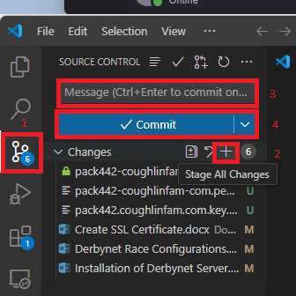

1. Click Sync Changes.

1. Click **OK**.

